Test Case: tc002_SPX_Dev5_Crear_Requisicion_Spot_Con_FAD_Tipo_Cobro_CC
Step 1 - Enter username and password and click to button Enter : Credentials Entered
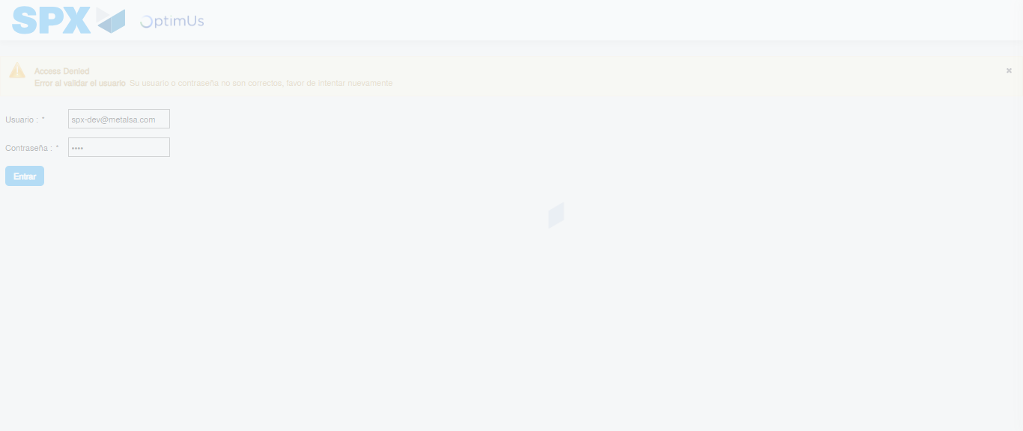Image file-name: QC_Testing-tc002_SPX_Dev5_Crear_Requisicion_Spot_Con_FAD_Tipo_Cobro_CC-1789484146122

Step 2 - Select to UEN and Access to Spot Buy Requisitions : UEN Correctly selected and Correct access
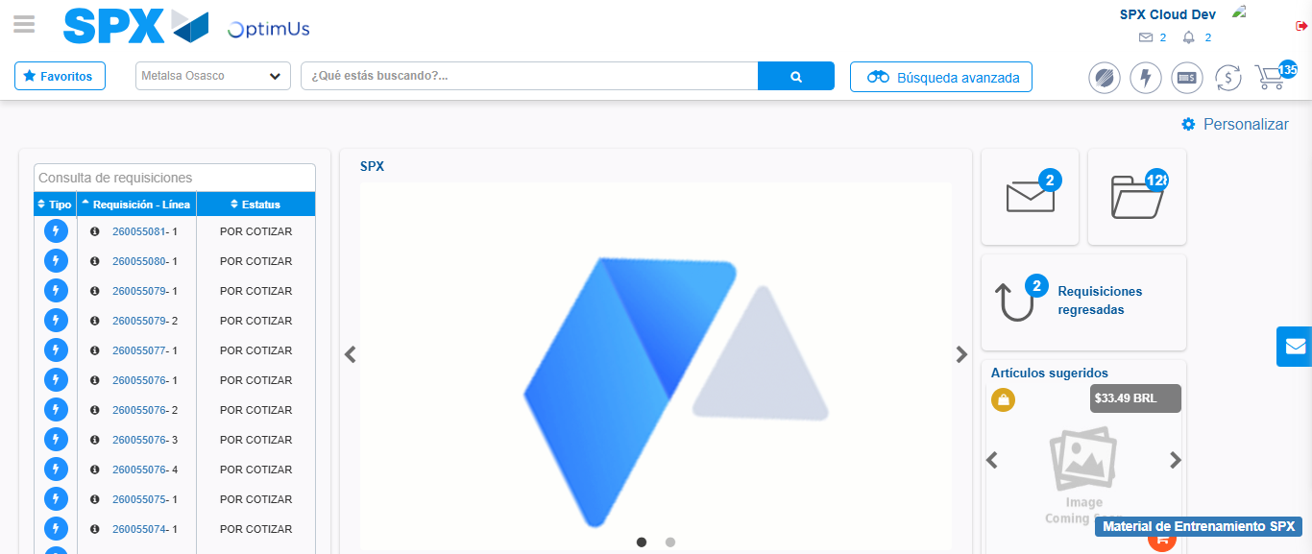Image file-name: QC_Testing-tc002_SPX_Dev5_Crear_Requisicion_Spot_Con_FAD_Tipo_Cobro_CC-1789484169090

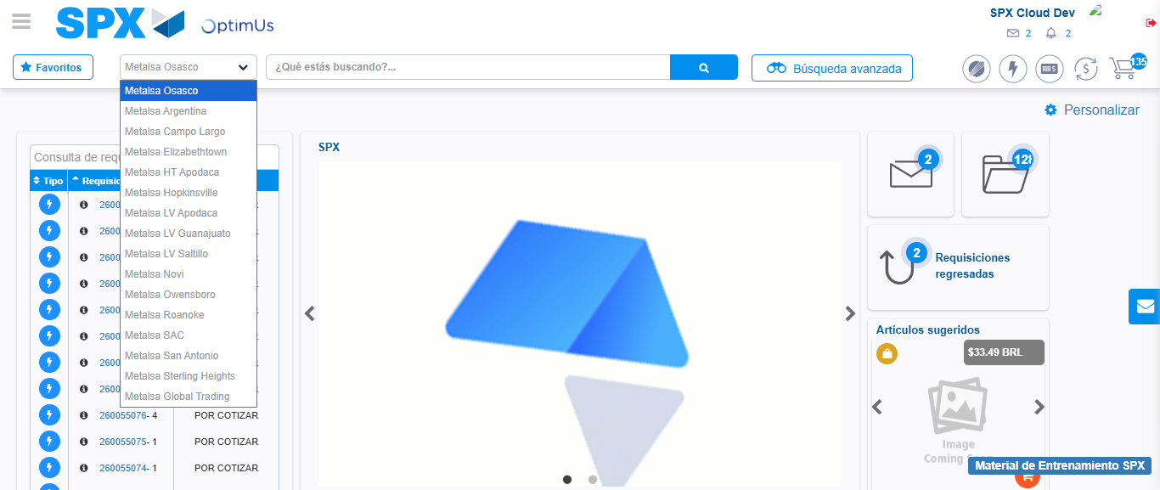Image file-name: QC_Testing-tc002_SPX_Dev5_Crear_Requisicion_Spot_Con_FAD_Tipo_Cobro_CC-1789484169548

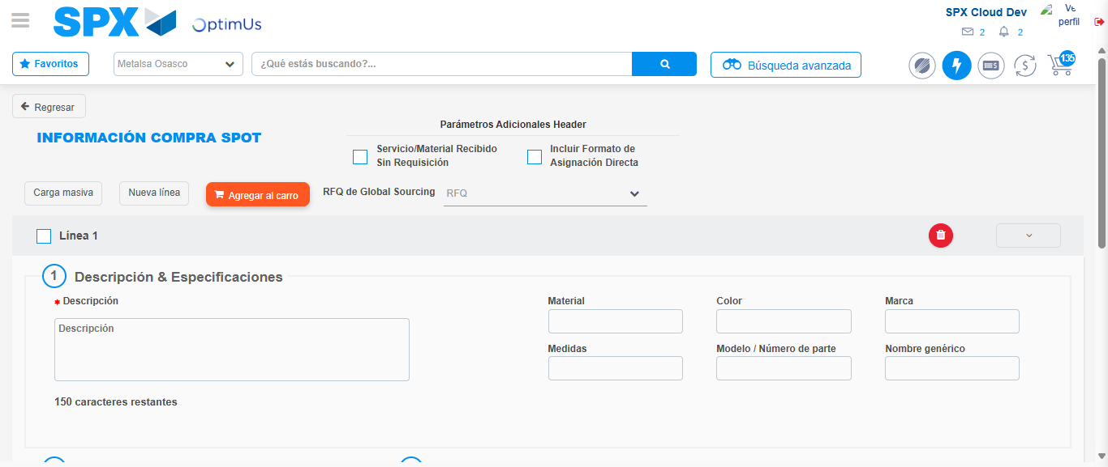Image file-name: QC_Testing-tc002_SPX_Dev5_Crear_Requisicion_Spot_Con_FAD_Tipo_Cobro_CC-1789484173927

Step 3 - Add FAD to Requisition: FAD Successfully Added
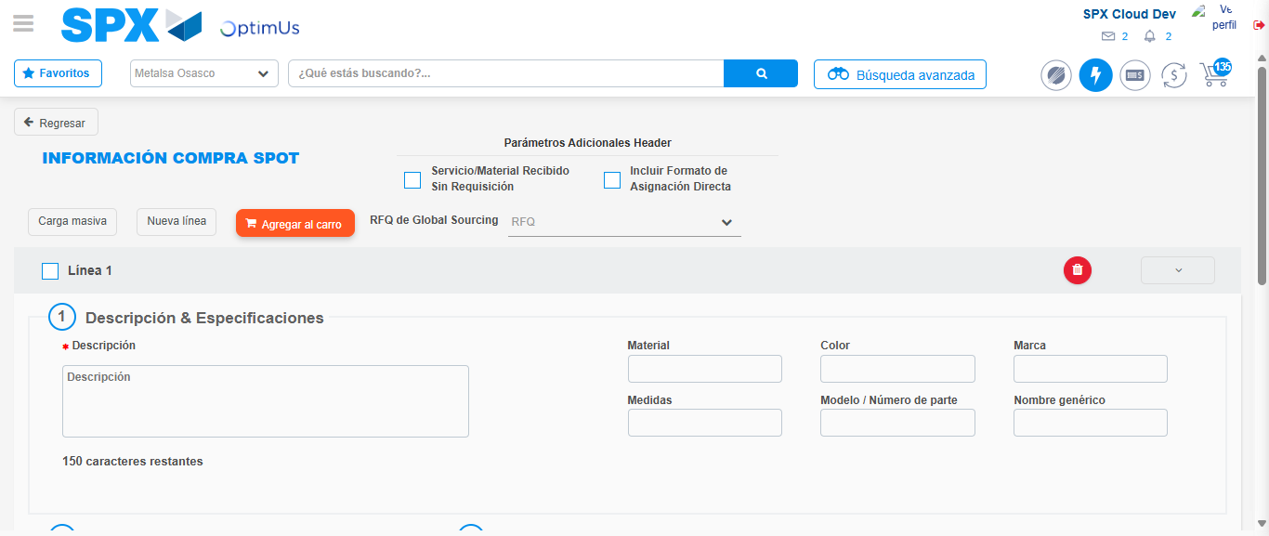Image file-name: QC_Testing-tc002_SPX_Dev5_Crear_Requisicion_Spot_Con_FAD_Tipo_Cobro_CC-1789484174136

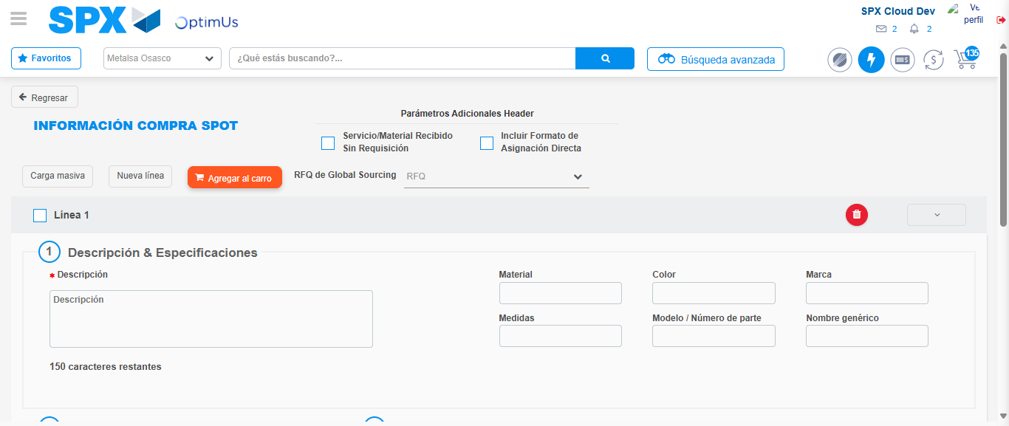Image file-name: QC_Testing-tc002_SPX_Dev5_Crear_Requisicion_Spot_Con_FAD_Tipo_Cobro_CC-1789484174279

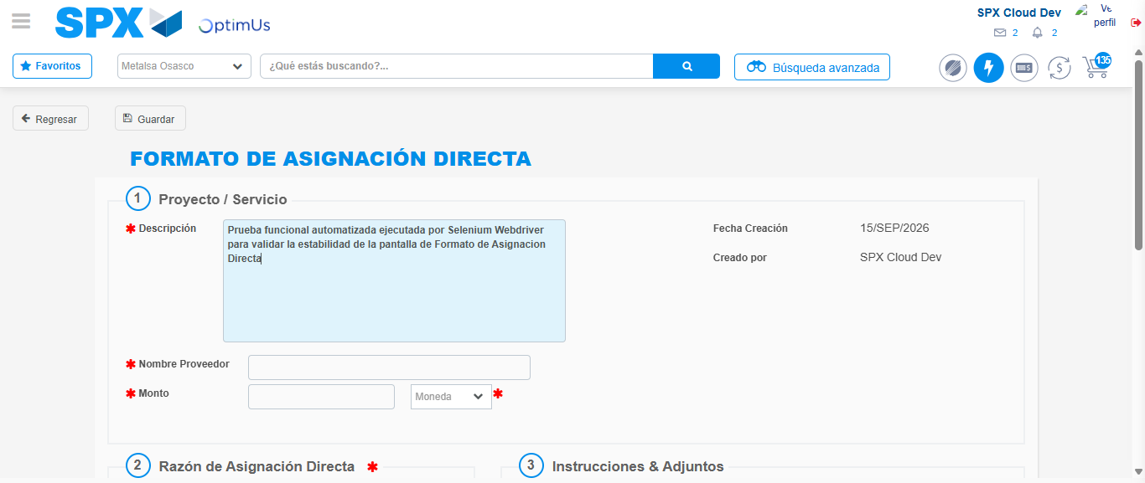Image file-name: QC_Testing-tc002_SPX_Dev5_Crear_Requisicion_Spot_Con_FAD_Tipo_Cobro_CC-1789484177101

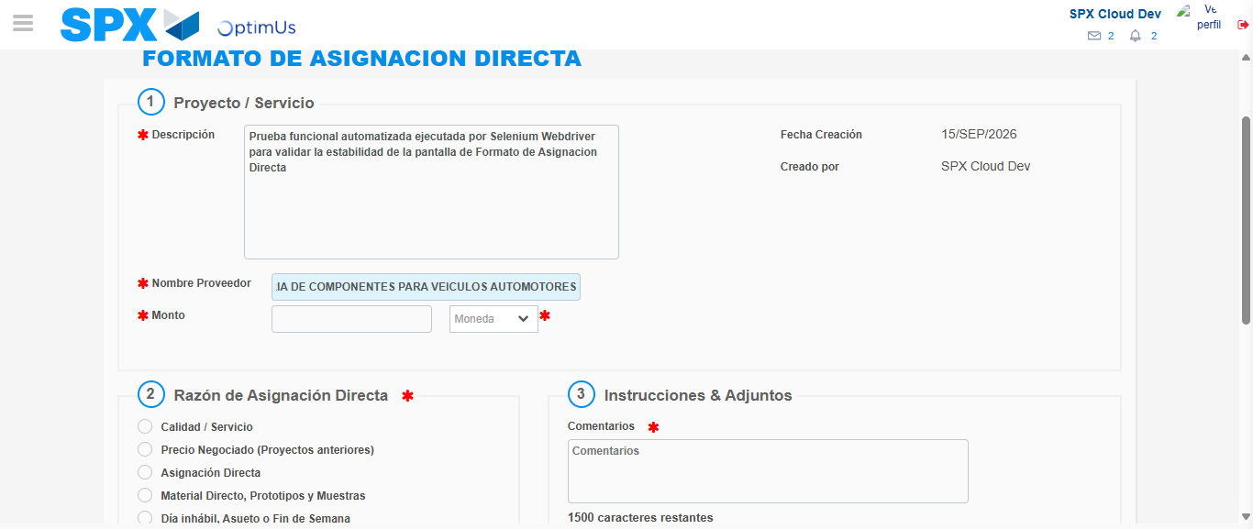Image file-name: QC_Testing-tc002_SPX_Dev5_Crear_Requisicion_Spot_Con_FAD_Tipo_Cobro_CC-1789484186012

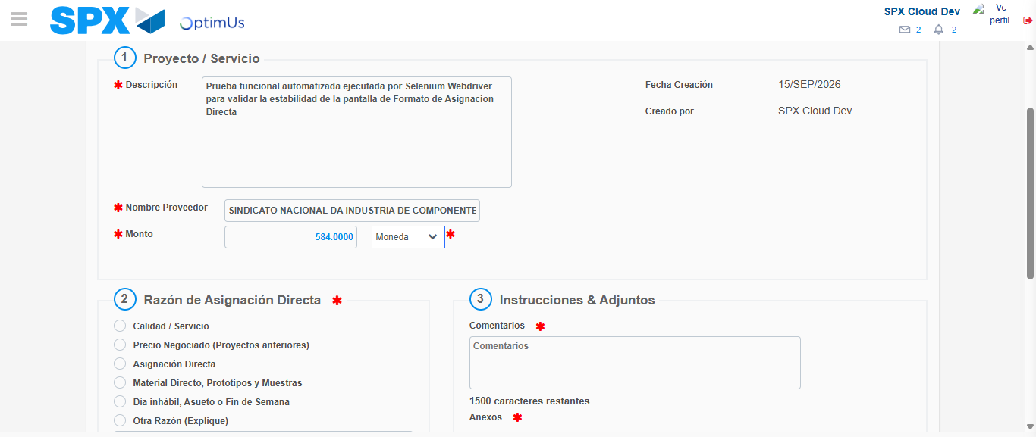Image file-name: QC_Testing-tc002_SPX_Dev5_Crear_Requisicion_Spot_Con_FAD_Tipo_Cobro_CC-1789484186441

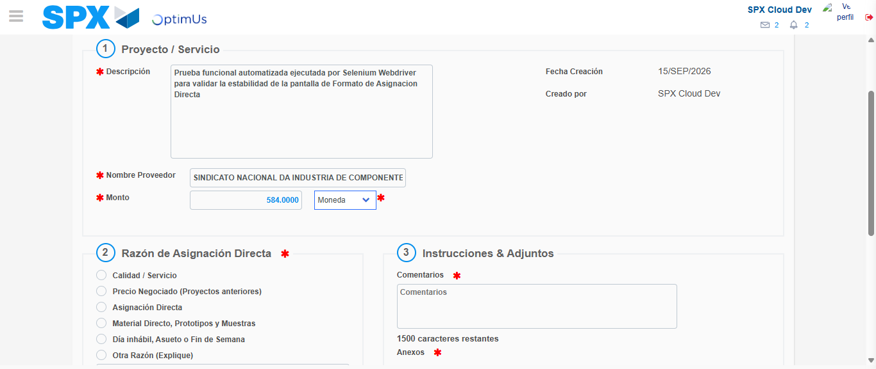Image file-name: QC_Testing-tc002_SPX_Dev5_Crear_Requisicion_Spot_Con_FAD_Tipo_Cobro_CC-1789484186614

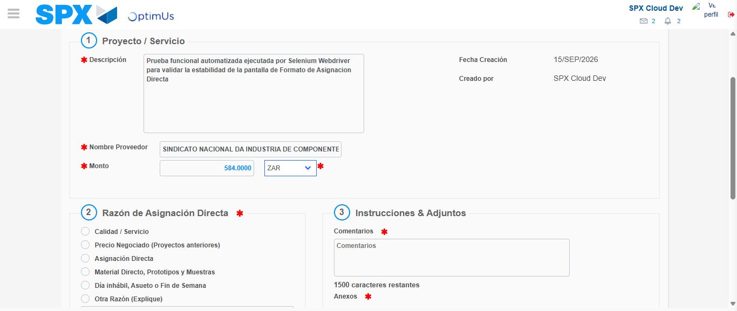Image file-name: QC_Testing-tc002_SPX_Dev5_Crear_Requisicion_Spot_Con_FAD_Tipo_Cobro_CC-1789484186969

Image file-name: QC_Testing-tc002_SPX_Dev5_Crear_Requisicion_Spot_Con_FAD_Tipo_Cobro_CC-1789484187129

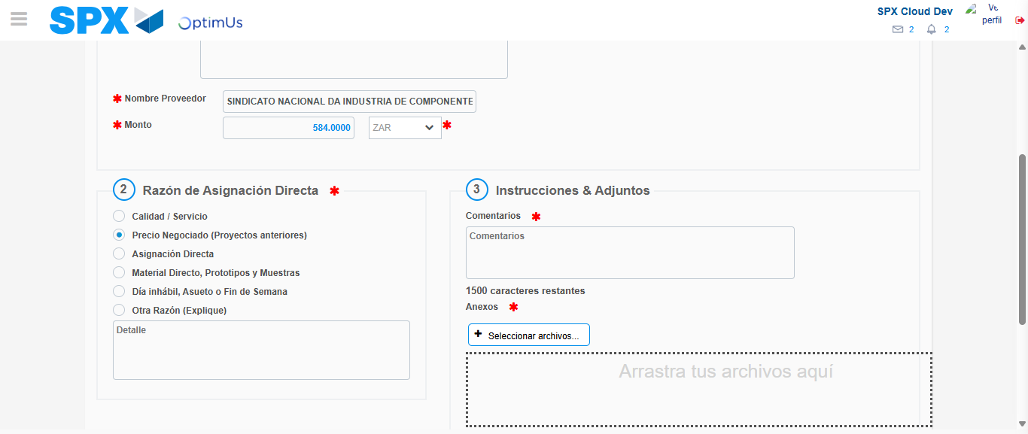Image file-name: QC_Testing-tc002_SPX_Dev5_Crear_Requisicion_Spot_Con_FAD_Tipo_Cobro_CC-1789484187924

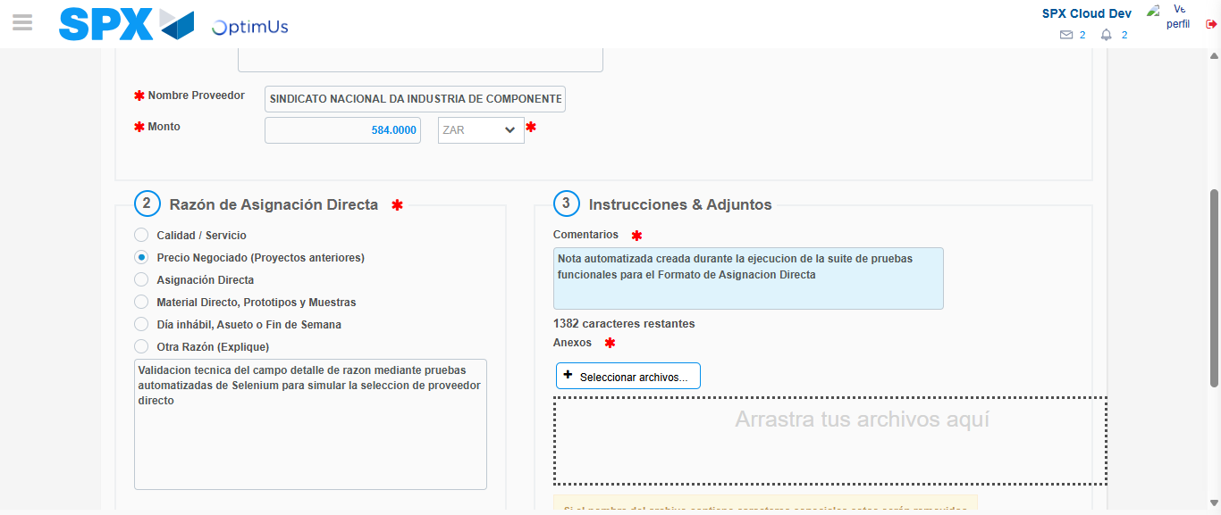Image file-name: QC_Testing-tc002_SPX_Dev5_Crear_Requisicion_Spot_Con_FAD_Tipo_Cobro_CC-1789484199035

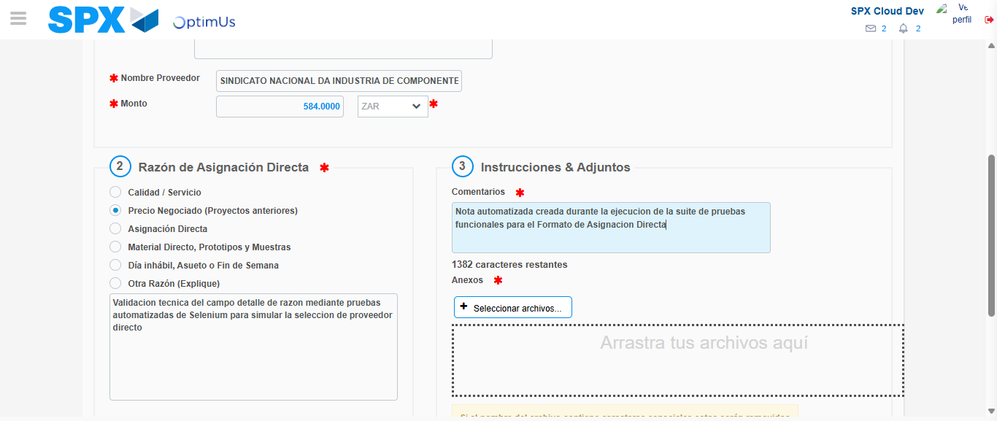Image file-name: QC_Testing-tc002_SPX_Dev5_Crear_Requisicion_Spot_Con_FAD_Tipo_Cobro_CC-1789484199624

Step 4 - Data Capture Spot Buy Requisition: Data captured correctly
Image file-name: QC_Testing-tc002_SPX_Dev5_Crear_Requisicion_Spot_Con_FAD_Tipo_Cobro_CC-1789484174136

Image file-name: QC_Testing-tc002_SPX_Dev5_Crear_Requisicion_Spot_Con_FAD_Tipo_Cobro_CC-1789484174279

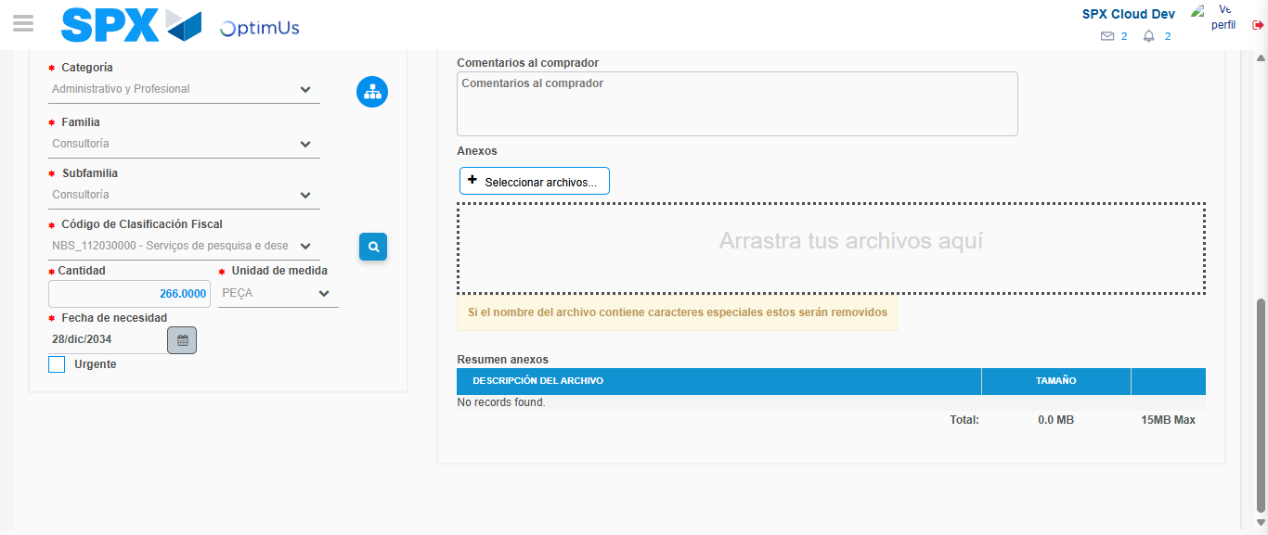Image file-name: QC_Testing-tc002_SPX_Dev5_Crear_Requisicion_Spot_Con_FAD_Tipo_Cobro_CC-1789484223898

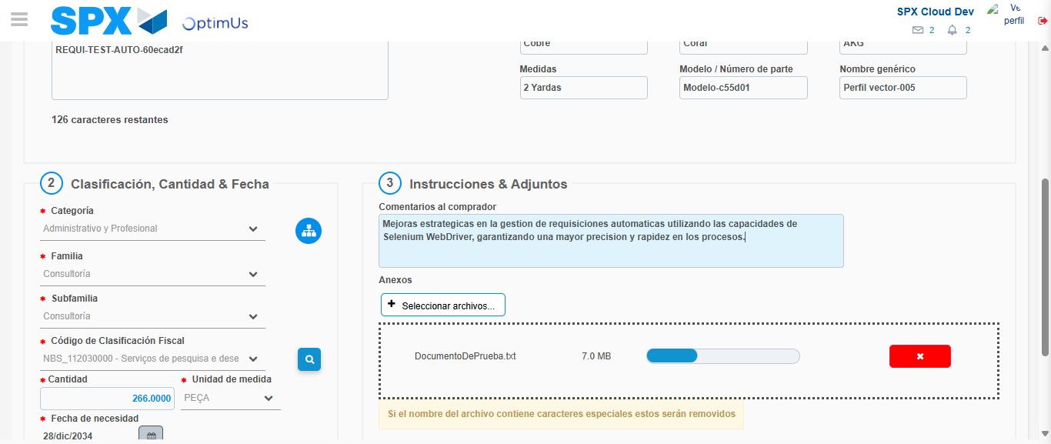Image file-name: QC_Testing-tc002_SPX_Dev5_Crear_Requisicion_Spot_Con_FAD_Tipo_Cobro_CC-1789484224825

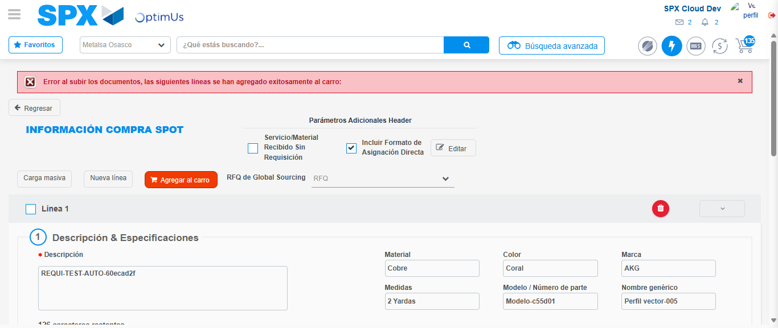Image file-name: QC_Testing-tc002_SPX_Dev5_Crear_Requisicion_Spot_Con_FAD_Tipo_Cobro_CC-1789484238758

Step 8 - Return to Main Page SPX : Return to Main Page SPX
Image file-name: QC_Testing-tc002_SPX_Dev5_Crear_Requisicion_Spot_Con_FAD_Tipo_Cobro_CC-1789484169090

Image file-name: QC_Testing-tc002_SPX_Dev5_Crear_Requisicion_Spot_Con_FAD_Tipo_Cobro_CC-1789484169548

Image file-name: QC_Testing-tc002_SPX_Dev5_Crear_Requisicion_Spot_Con_FAD_Tipo_Cobro_CC-1789484173927

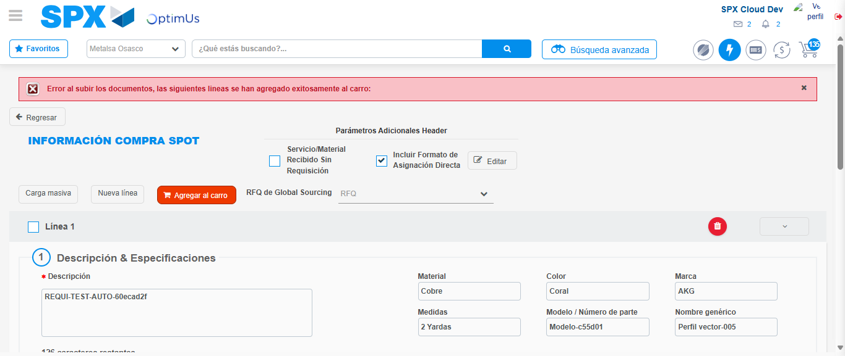Image file-name: QC_Testing-tc002_SPX_Dev5_Crear_Requisicion_Spot_Con_FAD_Tipo_Cobro_CC-1789484240983

Image file-name: QC_Testing-tc002_SPX_Dev5_Crear_Requisicion_Spot_Con_FAD_Tipo_Cobro_CC-1789484241177

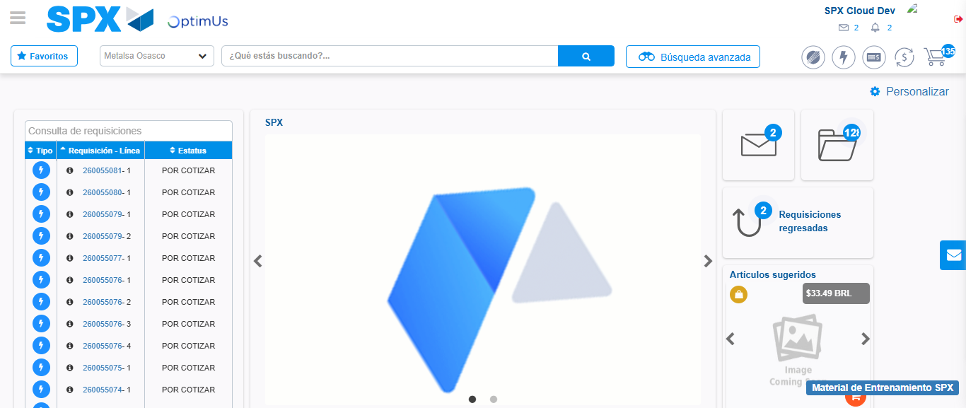Image file-name: QC_Testing-tc002_SPX_Dev5_Crear_Requisicion_Spot_Con_FAD_Tipo_Cobro_CC-1789484262249

Step 9 - Log Out : Log Out SPX
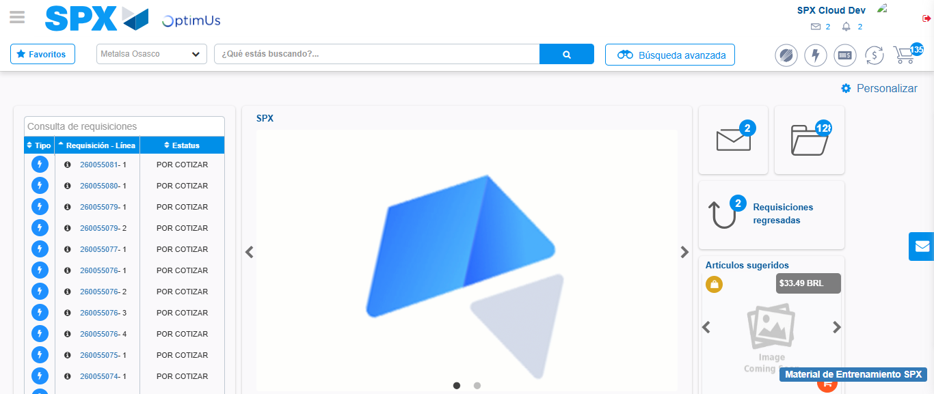Image file-name: QC_Testing-tc002_SPX_Dev5_Crear_Requisicion_Spot_Con_FAD_Tipo_Cobro_CC-1789484262510

